**Task 10: Compiling Maven in local server via Jenkins Source Code Management Configuration**

1. **The Maven project folder got generated in the local server**

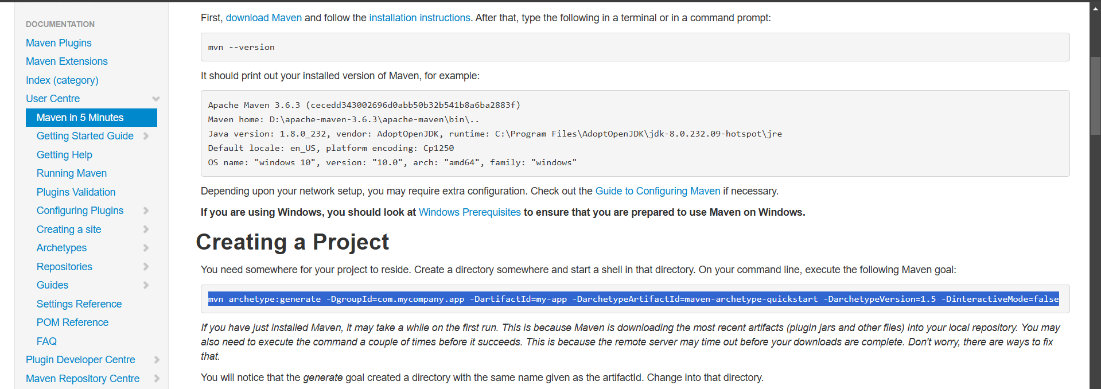

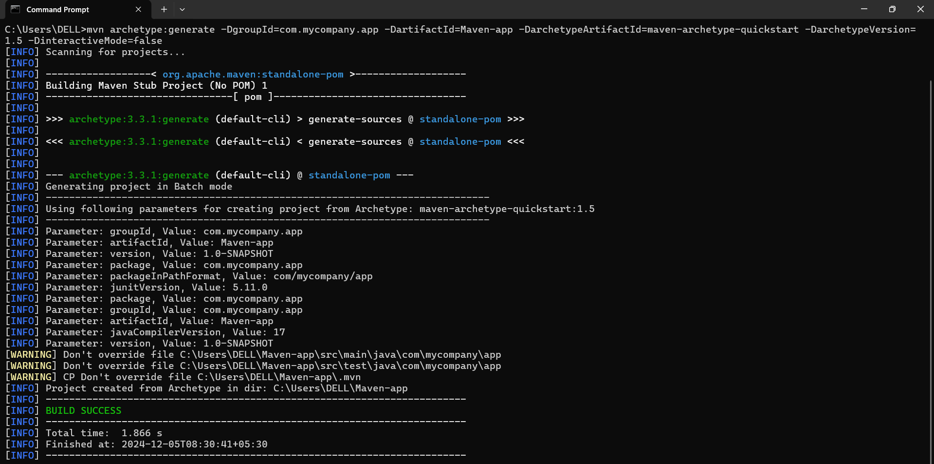

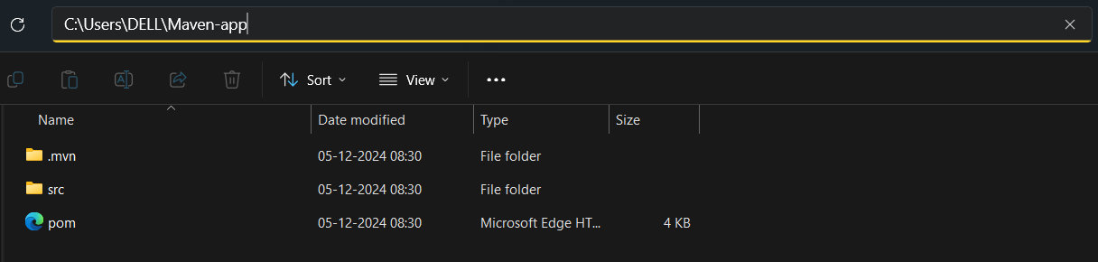

1. **A repository has created in the GitHub named “Maven” and The Maven project folder in the local repo has pushed into that particular GitHub repository**

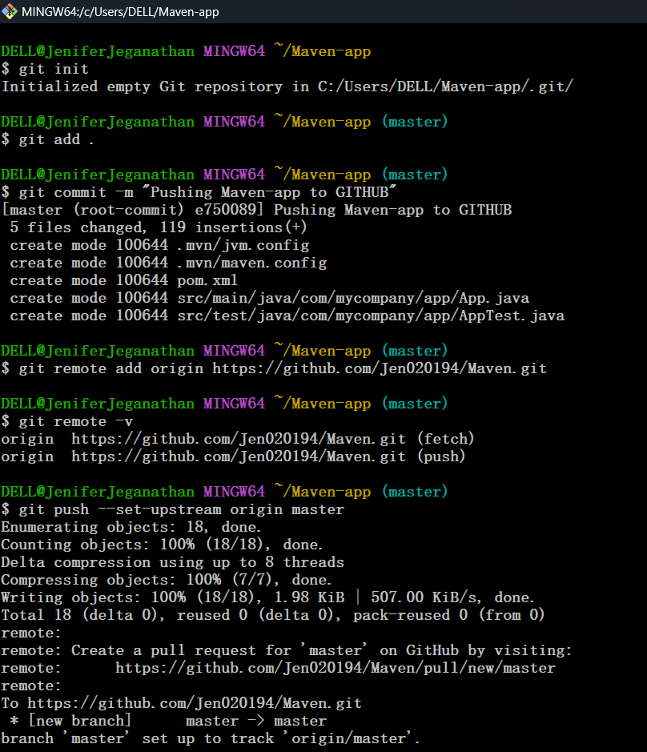

1. **The Source folder got successfully pushed into the remote repository**

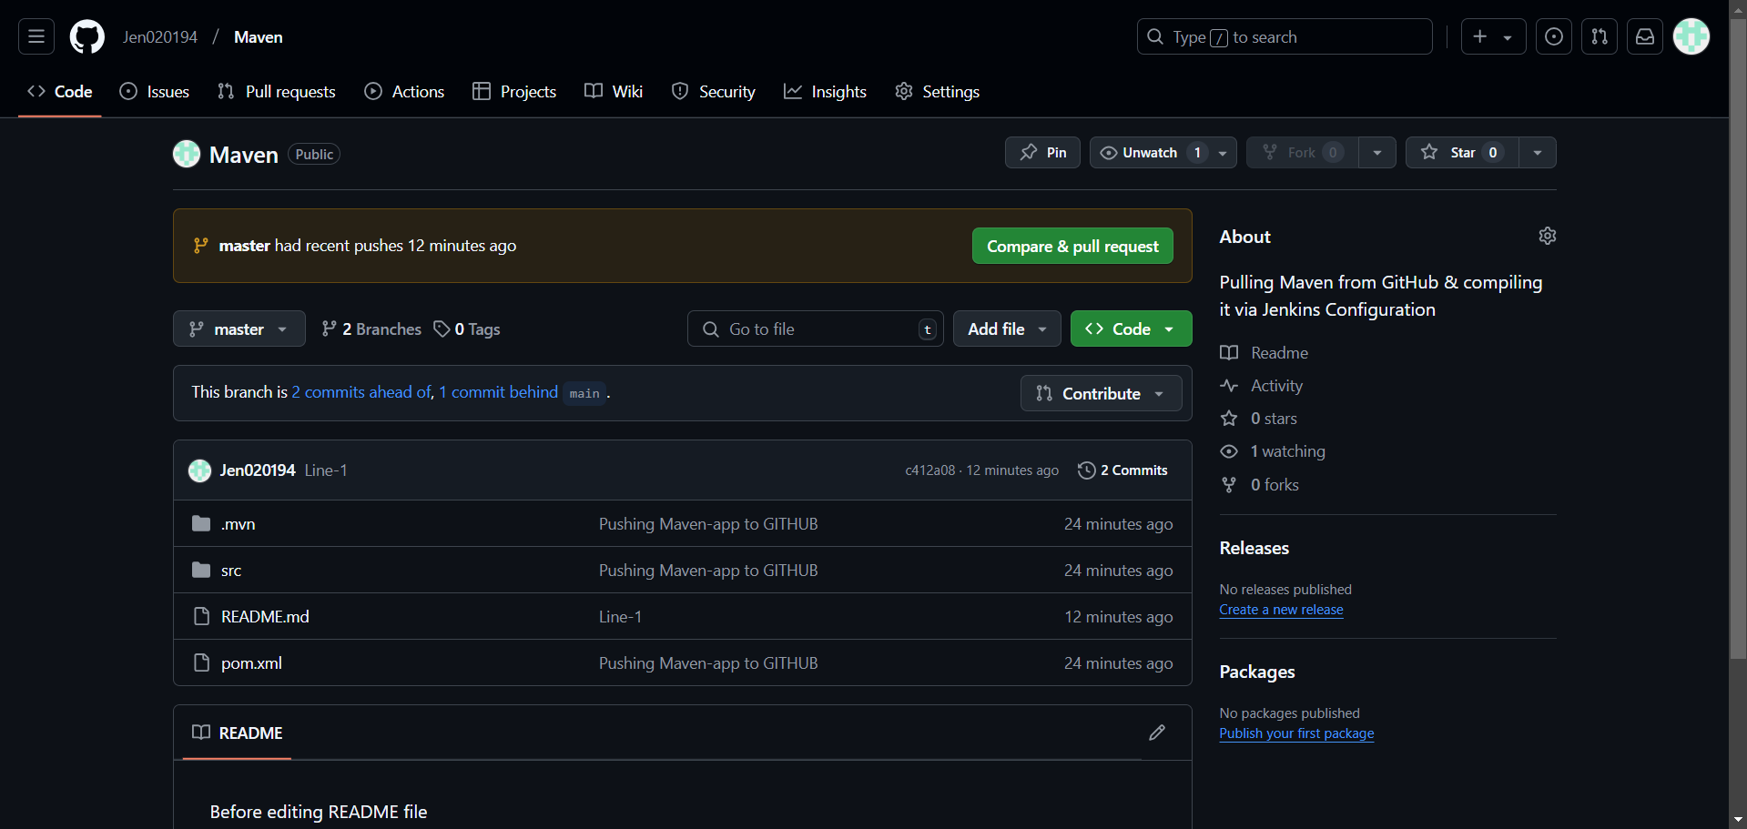

1. **Created a new job in Jenkins named “Maven_GIT” & Configured Source Code Management for the job by providing the appropriate Github repository link and branch name**

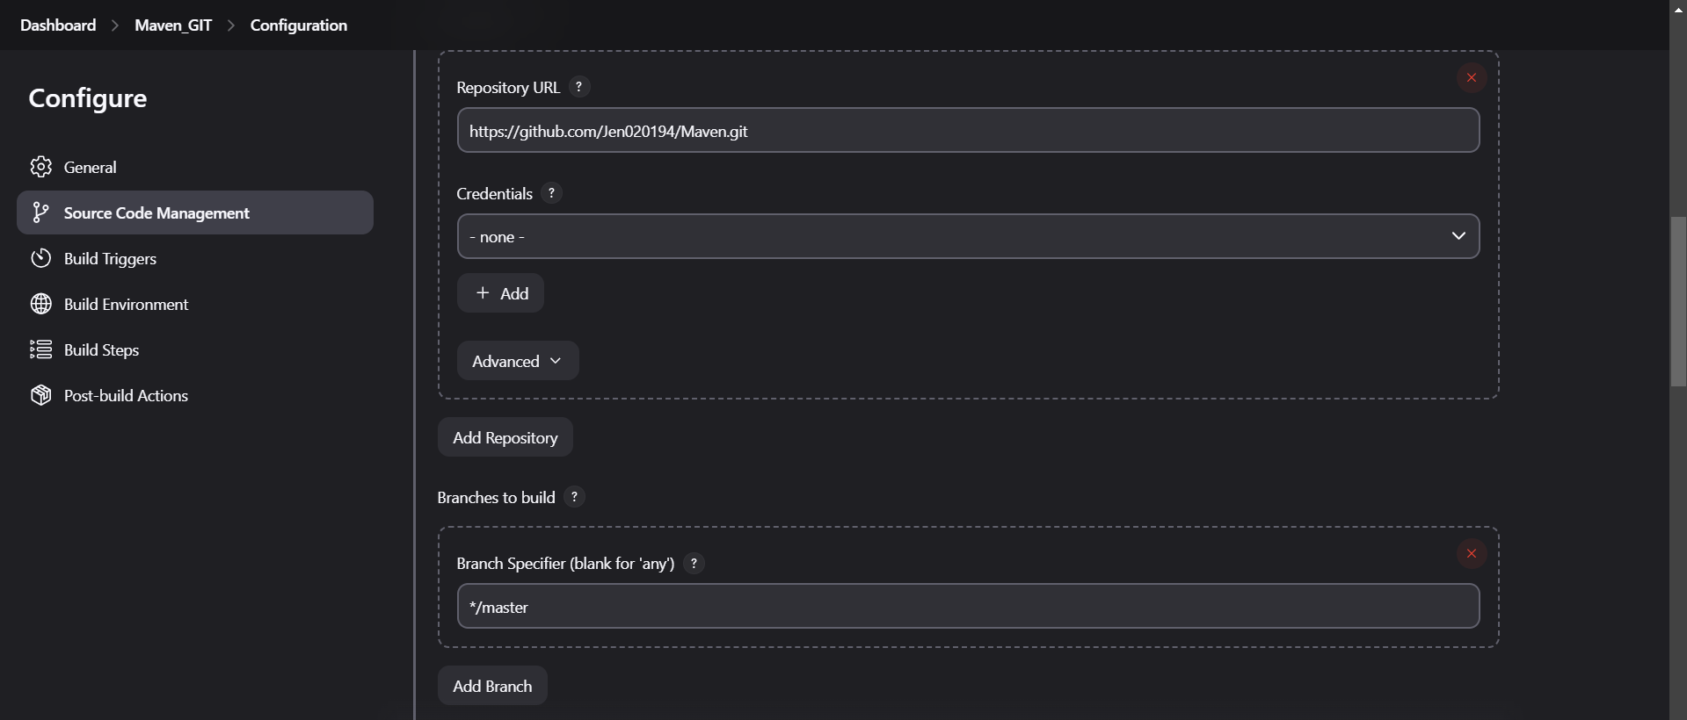

1. **Using “mvn compile” Command in Execute Windows Batch Command Build step we can compile the Maven folder & Click on Apply and Save**

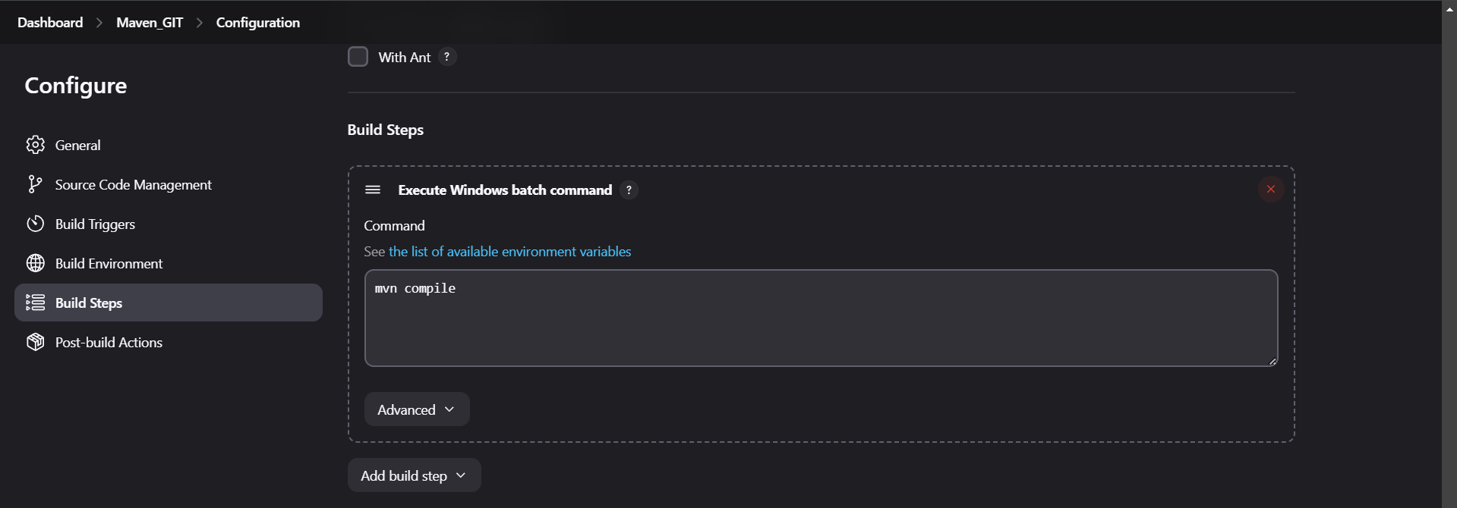

1. **The Console Output**

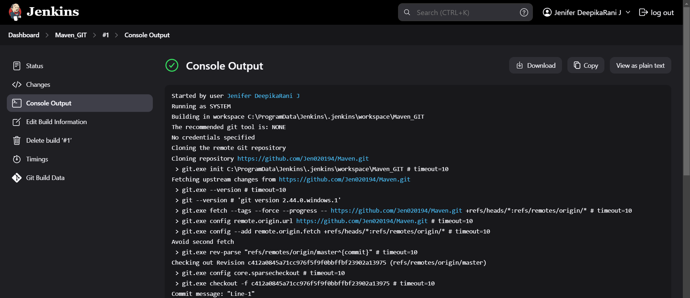

1. **As a result we can get the Target folder in the Jenkins workspace folder in our local repo**

